**EGEE 438: Wind and Hydropower Energy Conversion**

**Professor: Fernando Soto**

**Penn State University**

**Student Instruction Manual**

**Written by Luis Hinojosa & Muna Onuoha**

Hello and welcome to the DIFUSE Data Science Module on Wind Energy for EGEE 438!

# Module Summary

This module covers the topics in the course related to Wind Energy harvesting and development. Data science tools and techniques are utilised to explore primary concepts such as the wind power equations and will allow for student interaction with relevant data sets. This module is divided into three blocks:

**Block 1: The Wind Power Equations**

Students are introduced to the wind power equations and the relationships between them.

**Objectives**: At the end of this block, students will be able to

* recognize the wind power equations and their variables,
* describe the relationship between air density, wind speed, and blade area in calculating wind power (and wind power density),
* determine how air density changes with elevation and ground temperature,
* understand the relationship between air density and pressure,
* predict how wind speed changes with elevation and terrain conditions, and
* visualize the relationships between all these variables by creating graphs and plots.

**Block 2: Some Statistical Concepts**

Students will review statistical measures (mean, median, frequency) that quantify real wind speed data sets from various regions.

**Objectives**: At the end of this block, students will be able to

* describe how wind speed is measured
* understand how wind speed impacts power output,
* outline the benefits and detriments of high wind speeds,
* analyze wind speed data from different regions using tools such as frequency tables
* work with wind data to draw with meaningful conclusions
* estimate what the best wind speed is in a given region

**Block 3: Wind Power Production in Real Life**

Students will observe wind turbines and their capacity for power production. Wind farm siting considerations are also highlighted.

**Objectives**: At the end of this block, students will be able to

* recognize the limits of the wind power equations,
* interpret a wind turbine's power curve,
* define and calculate the capacity factor of a wind turbine, and
* interact with regional wind speed data to calculate capacity factors for different turbines

# How to Start

* The folder “WindEnergyModuleMaterials” should be available in your Google Drive after your instructor shares it with you.
* You can open each block with Google Co-Laboratory
  + Right Click > Open With > Google Co-Laboratory

## 

* Alternatively, if you are opening the module on an ***iPad or tablet***, you will need a browser.
* Open your Google Drive on your browser (Chrome or Safari works best)
* Locate the module and open with Google Co-Laboratory
* Tap file > Click vertical dots in menu > Open With > Google Co-Laboratory

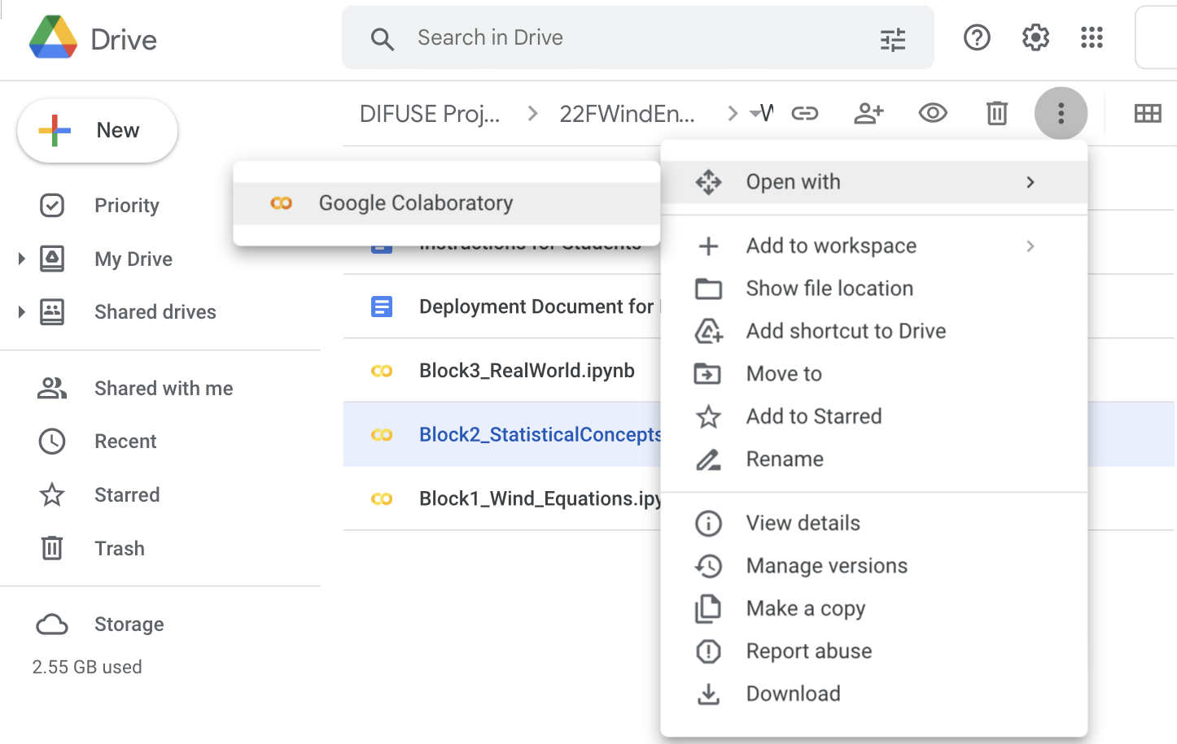

* Read the instructions at the beginning of each block before commencing.

There is a code script you must run first in each block to initialise the tools you need.

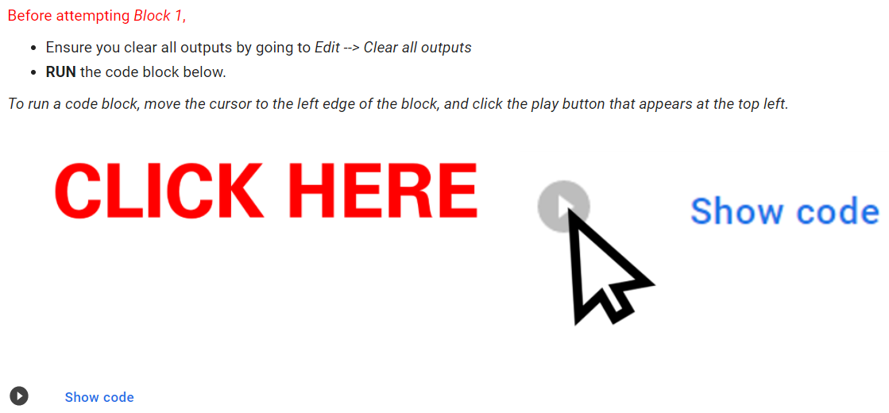

# Extras & Troubleshooting

## Table of contents

To toggle the table of contents, click the three horizontal lines in the top left corner of the side-bar. You can then easily navigate to certain sections in the module by clicking on it.

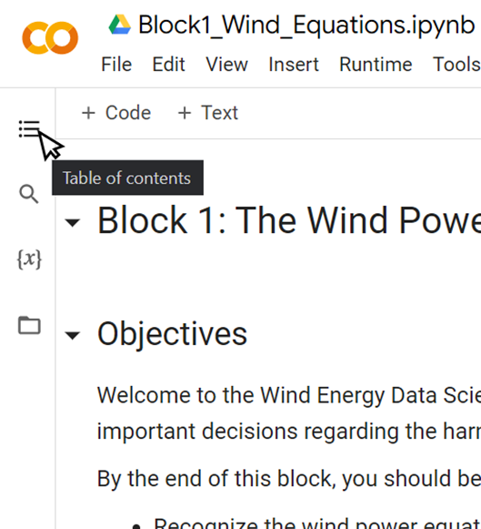 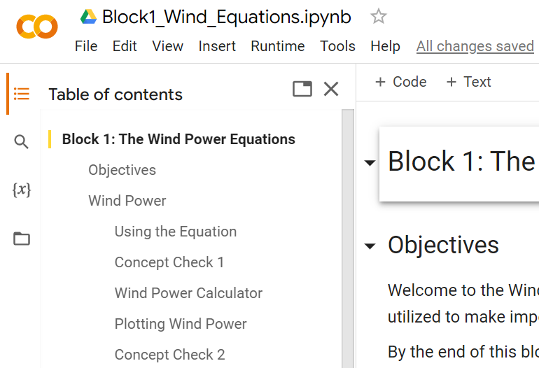

## Hide code

In this module, all the code is automatically hidden. If you reveal code and want to hide it again, you can do so by right-clicking on the code section (or tapping the three dots on the top right)

* Right Click > Form > Hide code

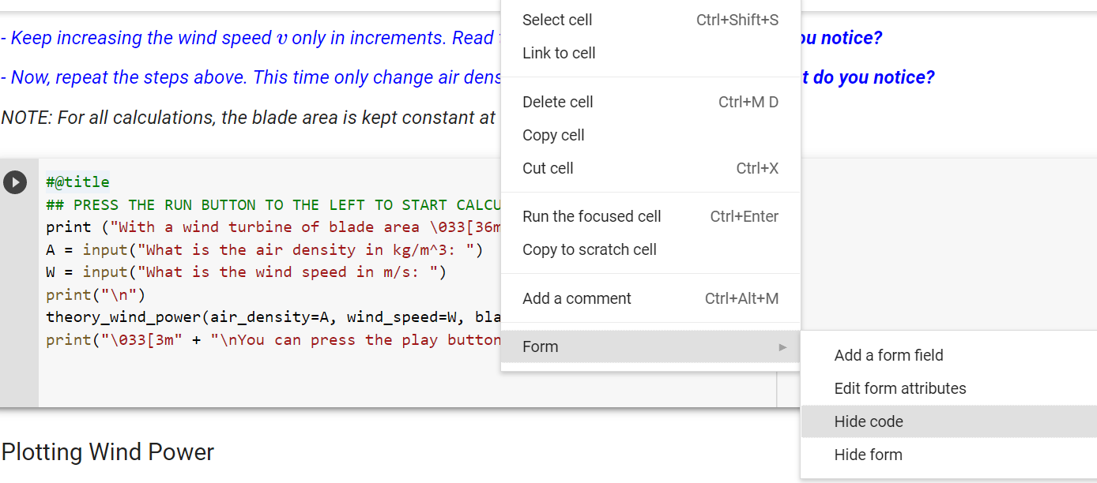

* Tap three dots > Form > Hide code

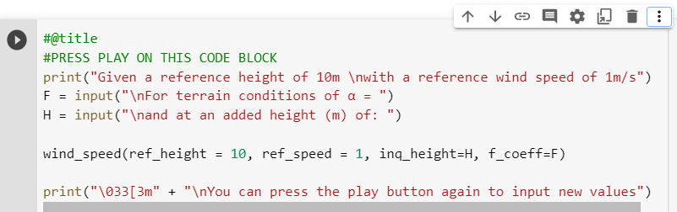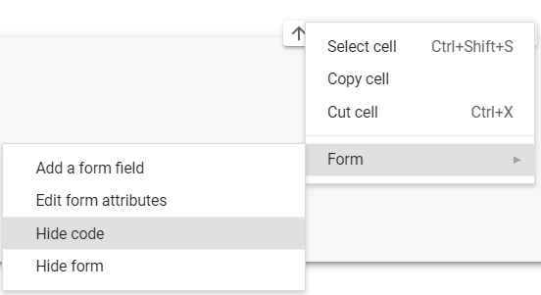

## Deleted or edited code

* If the code, or any content, of the module is unwittingly edited. Simply refresh the page and it will go back to its original form. *As a student, you cannot make permanent changes to the module.*

## Images not showing on iPad/Tablet?

If images are not loading when you view the module on an iPad like so,

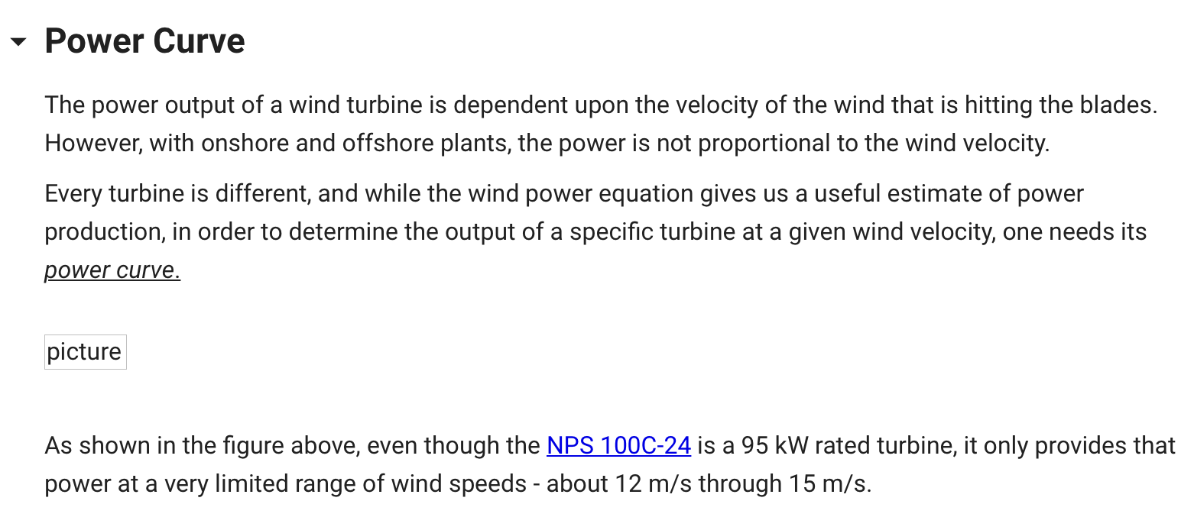

it can typically be corrected by using another browser like Safari or Google Chrome

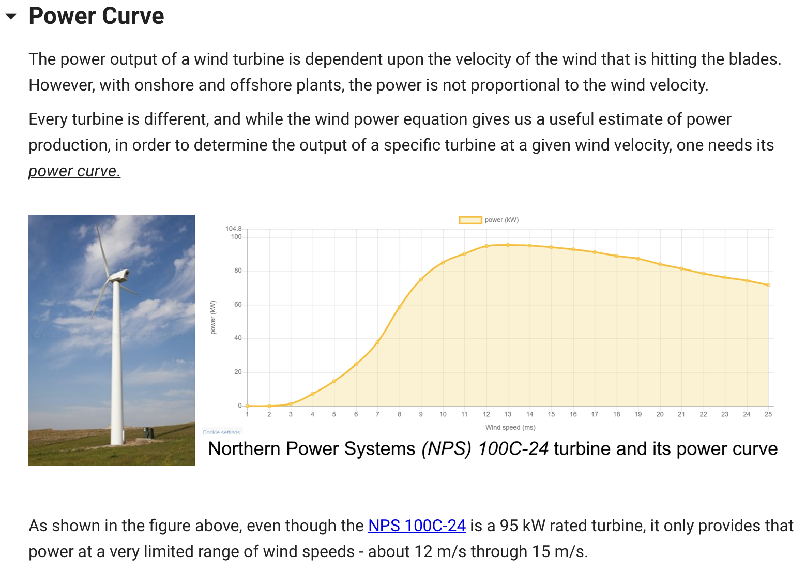

## 

## Code not working/crashing?

* Before working through any block, it is imperative that you run the initial code section at the beginning below the Objectives.
* If this has been done, and the code is still crashing, try refreshing the page.
* If the problem persists, contact your instructor.

## Other errors

* Keyboard Interrupt: occurs when user-input code sections are stopped before completing.

**FIX**: Simply rerun the code cell when this occurs. Ensure that you completely enter all data needed and allow the cell to run to completion

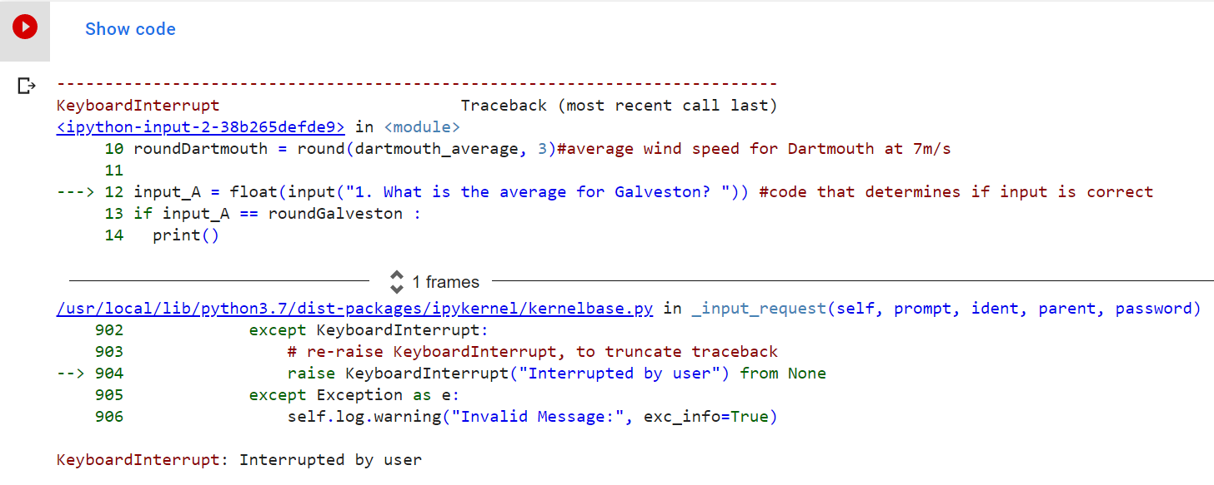

# Concept Checks

Throughout this module you will encounter text blocks labeled concept checks. These are designed to assist you in recalling and learning the topics introduced so far in the modules. Ensure that you work through them and raise any questions you may have to your professor.

**Block 1**

Concept Check #1: Relationship between variables in Theoretical Wind Power and Wind Power Density equations.

Concept Check #2: Plots of Wind Power against wind speed and against air density.

Concept Check #3: Effects of elevation and ground temperature on air density.

Concept Check #4: Change in Wind Speed with elevation and terrain type.

Concept Check #5: Effect on friction coefficient on *change* of wind speed with elevation.

Concept Check #6: Effect on choice of reference wind speed and height on calculated wind speeds.

**Block 2**

Concept Check #1: Impact of certain wind speeds on energy production.

Concept Check #2: Histograms of wind speed frequencies in different locations.

**Block 3**

Concept Check #1: Reading the power curve of wind turbines.

Concept Check #2: Calculating actual energy output (table vs integration method).

Concept Check #3: Capacity factor check.

Concept Check #4: Siting a wind power plant (limitations of wind power equations).